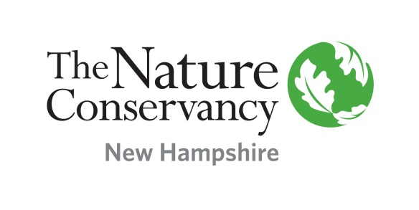  

April 19, 2016

The Honorable Nancy Stiles, Chairman

Committee on Transportation

Legislative Office Building, Room 103

Concord, NH 03301

Dear Chairman Stiles and members of the Committee:

Thank you for this opportunity to register our opposition to House Bill 1396, which would provide for an approval process to open certain state highways in Grafton County to OHRV use. While we understand that OHRV organizations in this region support the expansion of the State’s ATV network, we would urge the Committee to first carefully review the ability of state agencies to manage the current trail system before approving this bill.

During consideration of HB 1396 in the House Transportation Committee, the New Hampshire Fish and Game Department raised several specific concerns regarding law enforcement and safety. The agency noted that a large percentage of its core mission to enforce the laws, rules, and regulations pertaining to the state's fish, wildlife, and marine resources frequently takes a back seat to its obligations to respond to OHRV- related enforcement issues. Adding to this capacity crisis is the unfortunate reality that revenues from OHRV registrations to the Department have only recently reached 2007 levels, while the ATV trails network in the state has grown significantly since 2007.

We urge the Committee to take these concerns seriously. That the agency with primary responsibility for overseeing the ATV trail system believes they are not capable of properly managing the current system, let alone a larger system, should send an alarm signal to every group with an interest in this issue. While we urge the Committee to vote HB 1396 Inexpedient to Legislate, we also believe it presents an opportunity to initiate a larger discussion about the benefits and challenges of OHRV use in New Hampshire. We would welcome the opportunity to be part of such a discussion with all stakeholders. Thank you again.

Sincerely,

Susan Arnold Matt Leahy Jim O’Brien

Appalachian Mountain Club Society for the Protection of NH Forests The Nature Conservancy